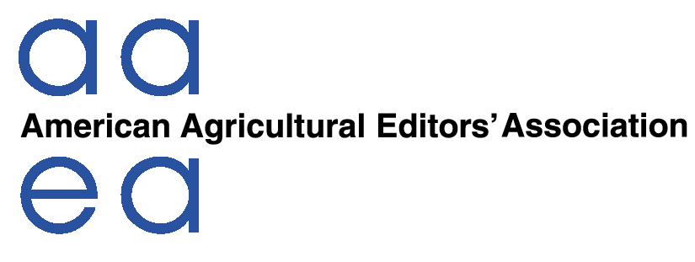
AAEA Professional Improvement Foundation
Ag Communicators Learning Mission to Cuba Application Form
A stipend program allocating $2,000 grants to ag communicators who are members of AAEA to attend an ag communicators learning mission in Cuba in the fall of 2016.
Please Note: An applicant must be a member of AAEA. (Please print or type)
Name:
Company:_______________________________
If Publishing Company, Note Print/Online Products You Work on: _______________________________________________________________________
________________________________________________________________________
Address:______
Phone (Work): Phone (Cell):
Email Address:
How did you hear of this award opportunity?___________________________________
Please provide the following in support of this application:
- A 500-word essay on why you should be selected to receive this stipend.
-How do you plan to use/publish information you gather on this tour?
-A resume or summary of your relevant work experience.

All entries will remain the property of the AAEA and its Foundation. Those selected will be notified by March 20, 2016.
As an applicant, I am aware that the Cuba mission cost is $4,000, plus the domestic cost to get to Miami, departure site for the trip. The AAEA Foundation stipend is for $2,000.
Signature of Applicant: __________________________________ Date:_________
*Signature of Applicant’s Supervisor:__________________________ Date: _________
*Applicant’s supervisor signature is required to assure that the applicant has approval to attend the mission should he/she be chosen. If the applicant receives a stipend but is unable to travel, the money granted must be returned to the AAEA Professional Improvement Foundation.
Please send completed entry and materials via email by (Feb. 29, 2016) to aaea@gandgcomm.com.

Q&A Regarding the Ag Communicators Learning Mission to Cuba
1. Who is eligible to apply for a stipend of $2,000 to attend the mission to Cuba?
Anyone who is a dues-paying member of AAEA. About 10-15 stipends will be awarded.
2. What is the actual cost to attend the mission?
The approximate cost for the Cuba portion of the trip is $4,000. This includes roundtrip airfare from Miami to Havana, hotel, meals, ground transfers and some miscellaneous costs for approximately six days. Thus, the stipend covers half of that cost. Costs to get to Miami for the departing flight are also not included. Participants will be responsible for covering remaining costs beyond their $2,000 stipends.
3. What will the mission consist of?
Tentatively, these may be included in the itinerary:
- Meetings with representatives of the Cuban Ag Ministry and other government officials
- Meetings with representatives of U.S. State Department
- Cuban ag economists from University of Havana
- Farms (tobacco, sugar cane, vegetables and other crops)
- Farm cooperative organizations
- Food processing and/or textile factory
- Cigar factory tour
- Supermarket (Mercado Agropecuario)
- El Trigal Wholesale Market
- Journalists who write about Cuban agriculture
- Other TBD activities
4. What is the timetable for the trip?
Applications are due Feb. 29, 2016. A committee will select the candidates by March 20, 2016. Considerable vetting of those to receive Media Visas will be handled in the second quarter. Depending on availability of hotels, speakers, etc., the timeframe for the six days will be from Sept. 18 through Sept. 26 OR Oct. 2 through Oct. 15 (six days during that time period).
5. What will I need to participate in this trip?
You will need a valid passport with two blank pages and an expiration date later than generally six months after proposed return to the U.S. More details on providing your passport to our tour operator will be known at a later date, but certainly in the second quarter of this year.
6. What if I’m not chosen for one of the 10 to 15 stipends?
AAEA will leave 5-10 slots open for members who wants to pay the full $4,000 to attend the mission. Details regarding implementation of this plan are under consideration.
7. Will there be any requirements for me if selected to receive a grant?
Yes, the foundation requires you to write about your experiences in our internal newsletter – The Byline – and provide to AAEA copies of materials you develop for publications, newsletters or online work related to the trip.
8. Are there any limitations on how many people from the same company can apply for stipends?
While any AAEA member can apply, only one person per media company or organization will be eligible to receive a stipend. The goal is to help encourage more companies to have a chance to take part in this unique and historic mission to Cuba. AAEA reserves the right to consider special circumstances that could alter this limitation stipulation and all decisions of AAEA are final on the selection of the participants.
The End

